90kn Torque Head- Spec Sheet
Specification
The Drive Unit has been specially designed for installing screw piles. The torque gauge fitted allows the user to monitor the installation torque as the piles are installed. The 12no bolt flange output, 355PCD, 26Ø allows a variety of adaptors to be fitted.
The 90kn Torque head is designed to fit on 13-50T excavators. This head will develop a maximum of 90,000Nm torque at the required working pressures stated below-
Technical Information Specifications
- Max Pressure 300 Bar
- Max Flow 150l/min
- Max Speed 4.5rpm
- Net Weight 900kg without cradle, 1200kg including cradle.
- Body Width 550mm
- Powerhead length (from base to centre of pin) 1480mm
- 2no Hydraulic hoses have ¾ inch BSP female fittings.
Guidance of fitting/piping up torque heads correctly-
- Both hoses are to be connected to the bucket ram or an auxiliary feed which is not restricted. Be aware when connecting the hoses to the breaker line, the pressure settings on circuit can be restricted with a single way circuit. If you must use the breaker line it must be BI-DIRECTIONAL with the correct pressures.
- Flow rates should be a minimum of 150 litres per min, ideal flow rate is between 175-200 litres per min and the working pressures should be between 250 -300 Bar.
- Check all fittings for leaks before starting the installation process.
- Keep all fittings and connections clean. Dirt or grit will cause extreme damage to the torque head motor or excavator.

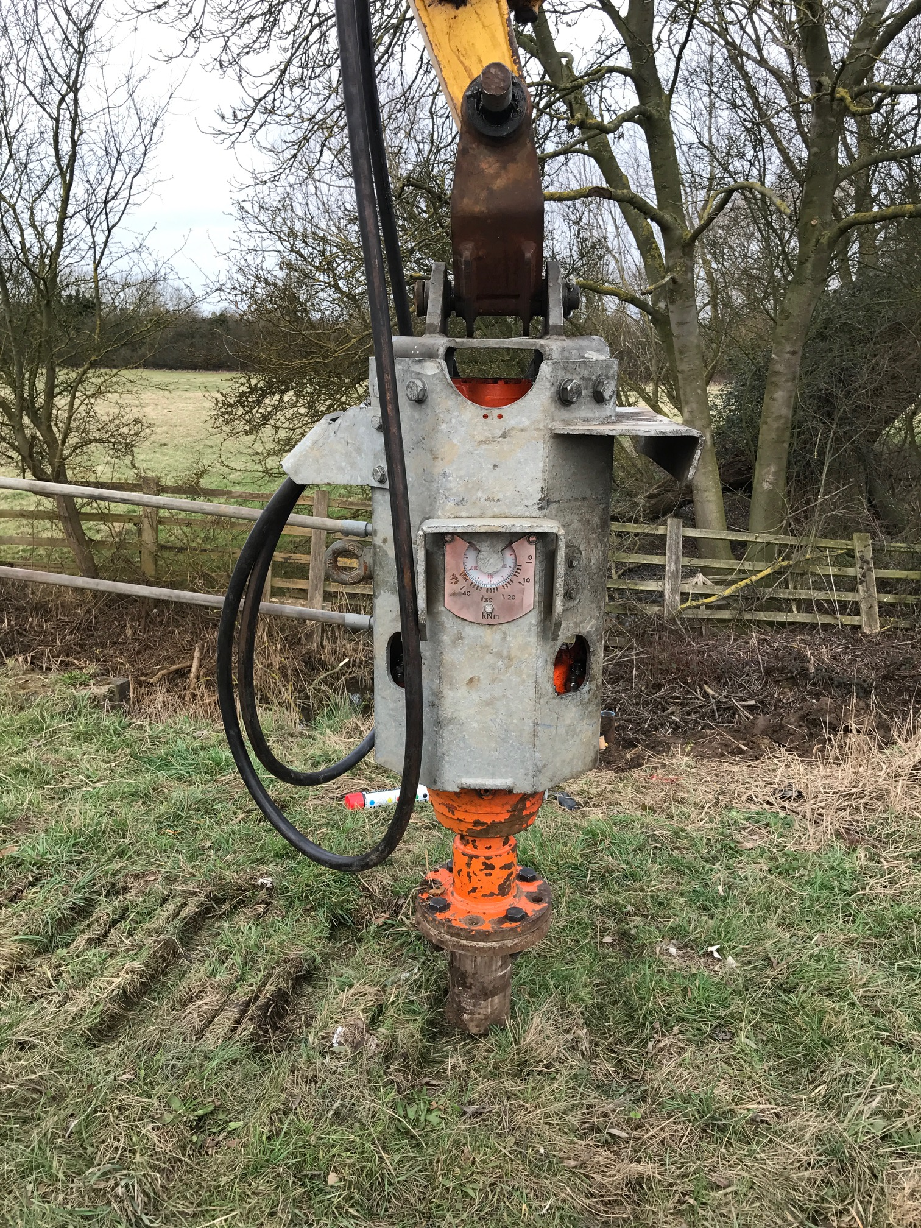
If you require any further technical information on the drive unit, please feel free to contact us on Info@ja-css.com

