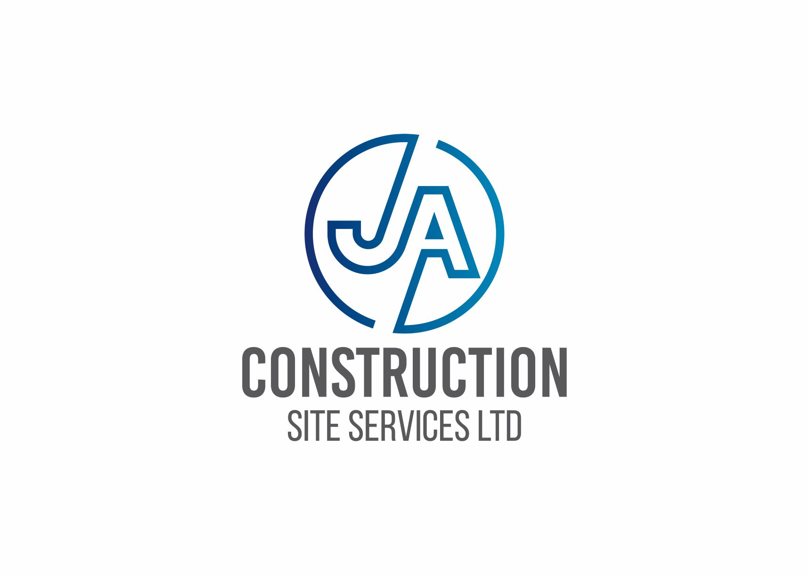
55-60kn Torque head - Spec Sheet
Specification:
The 6000X has been designed for installing screw piles. The torque gauge fitted allows the user to monitor the installation torque as the piles are installed. The 8 bolt flange output allows a variety of adaptors to be fitted.

The 6000X torque head is designed to fit 8-30t excavators. This head will develop 60,000Nm torque at working pressures stated below-
Technical Information Specifications
- Max Pressure 300 Bar
- Max Flow 150l/min
- Max Speed 7rpm
- Net Weight 480kg without cradle
- Body Width 470mm
- Powerhead length (from base to centre of pin) 1300mm
- 2no Hydraulic hoses have ¾ inch BSP female fittings.
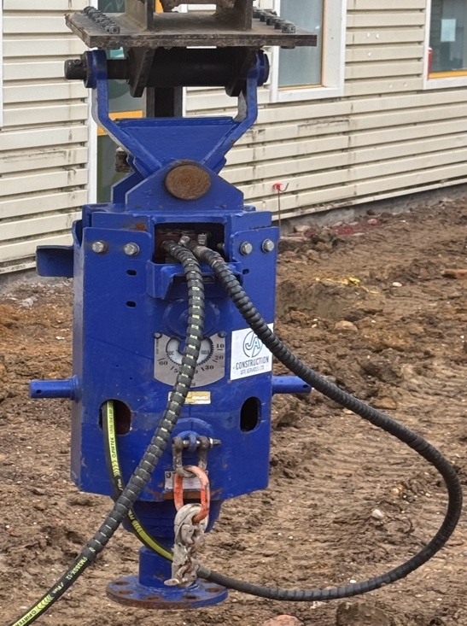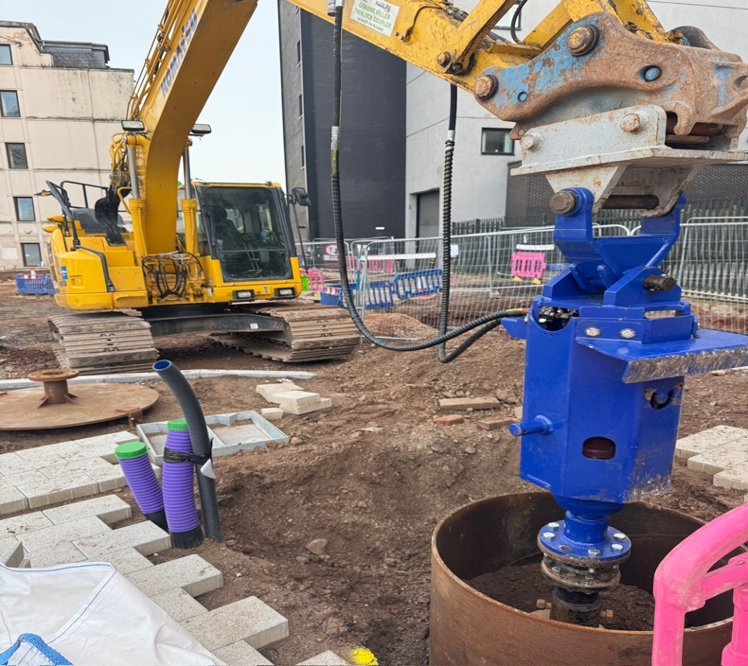
If you require any further technical information on the drive unit, please feel free to contact us on Info@ja-css.com

